update SC set Grade = Grade + 5

where Cno = (

select Cno from Course

where Cname = '数据库'

);

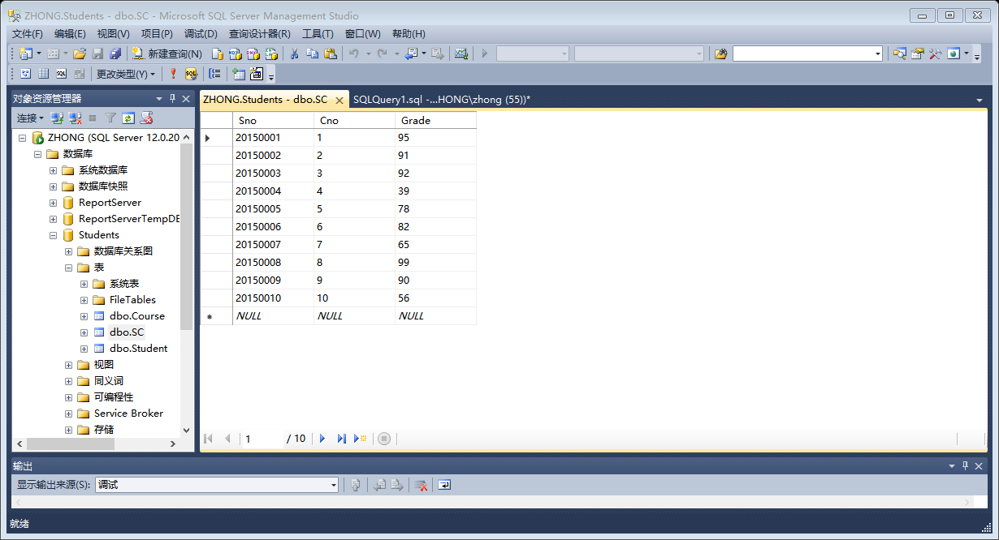

update SC set Grade = 0

where Sno in (

select Sno from Student

where Sdept = 'CS' and Cno = 2

);

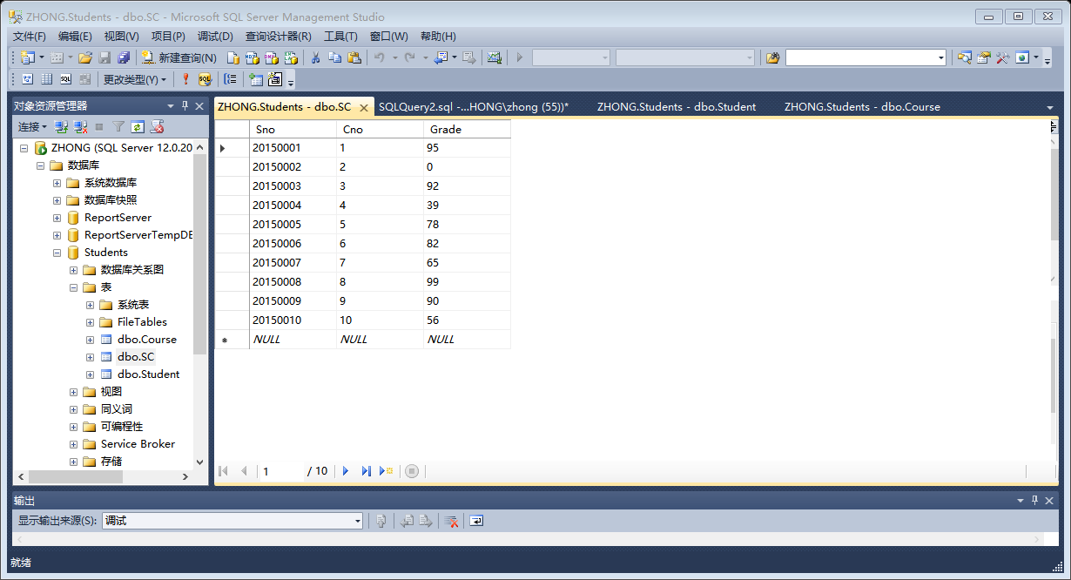

update SC set Grade = 85

where Sno = (

select Sno from Student

where Sname = '李勇'

)and Cno = (

select Cno from Course

where Cname = '数据库'

);

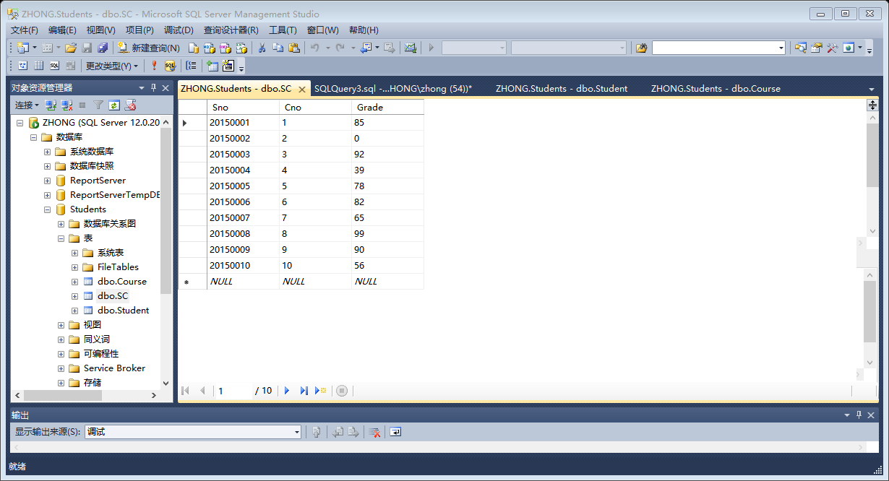

delete from SC

where Cno = 2 and Grade = 0;

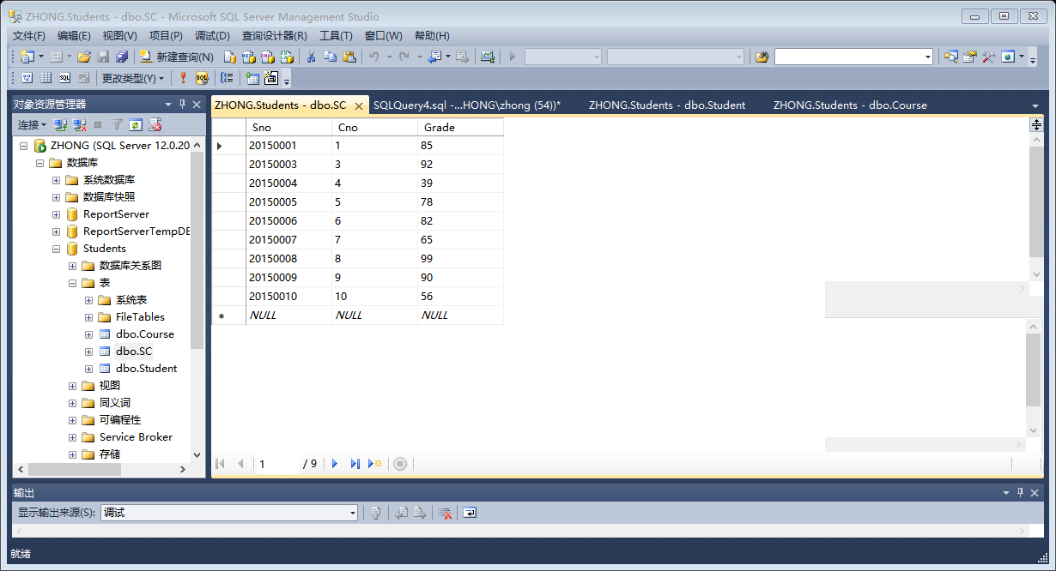

delete from Course

where Cno not in(

select Cno from SC

);

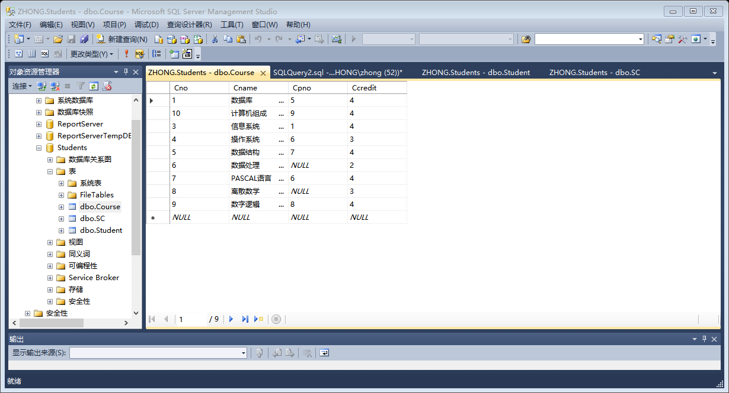

delete from SC

where Sno in(select Sno from Student where Sdept = 'CS')and

Cno = (select Cno from Course where Cname = '数据库');

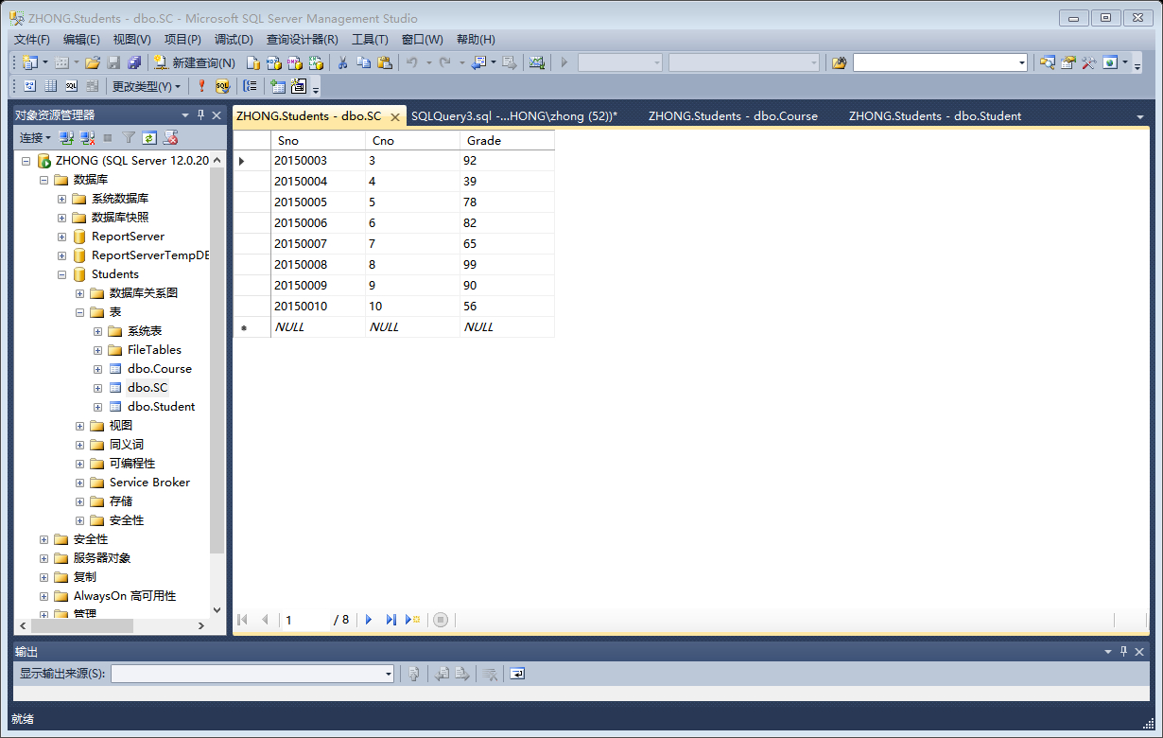

create view Department(Sdept,Ssex,nun) as

select Sdept,Ssex,Count(Ssex)

from Student

group by Sdept,Ssex;

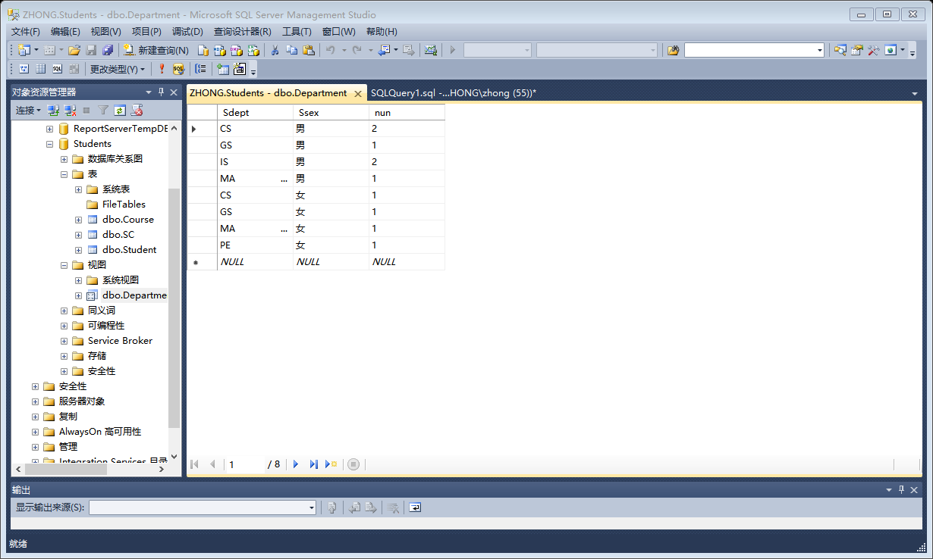

create view MOreThan80(Sno,Cnum,Ave) as

select Sno,Count(Cno),AVG(Grade)

from SC

group by Sno

having AVG(Grade)>=80;

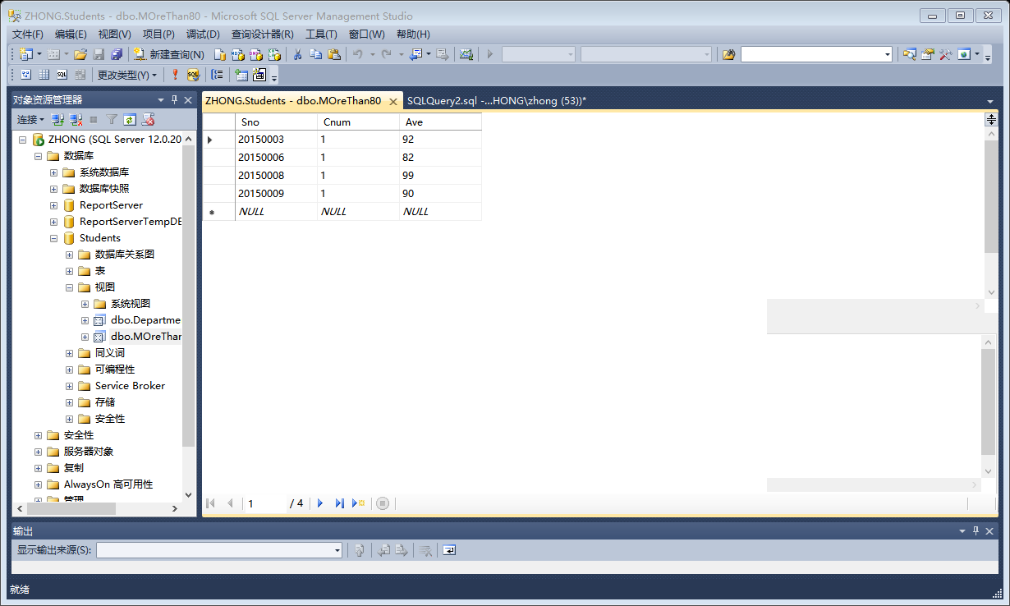

create view SNULL as

select distinct Student.Sno,Sname,Sdept

from Student,SC

where Student.Sno not in(

select Sno from SC

);

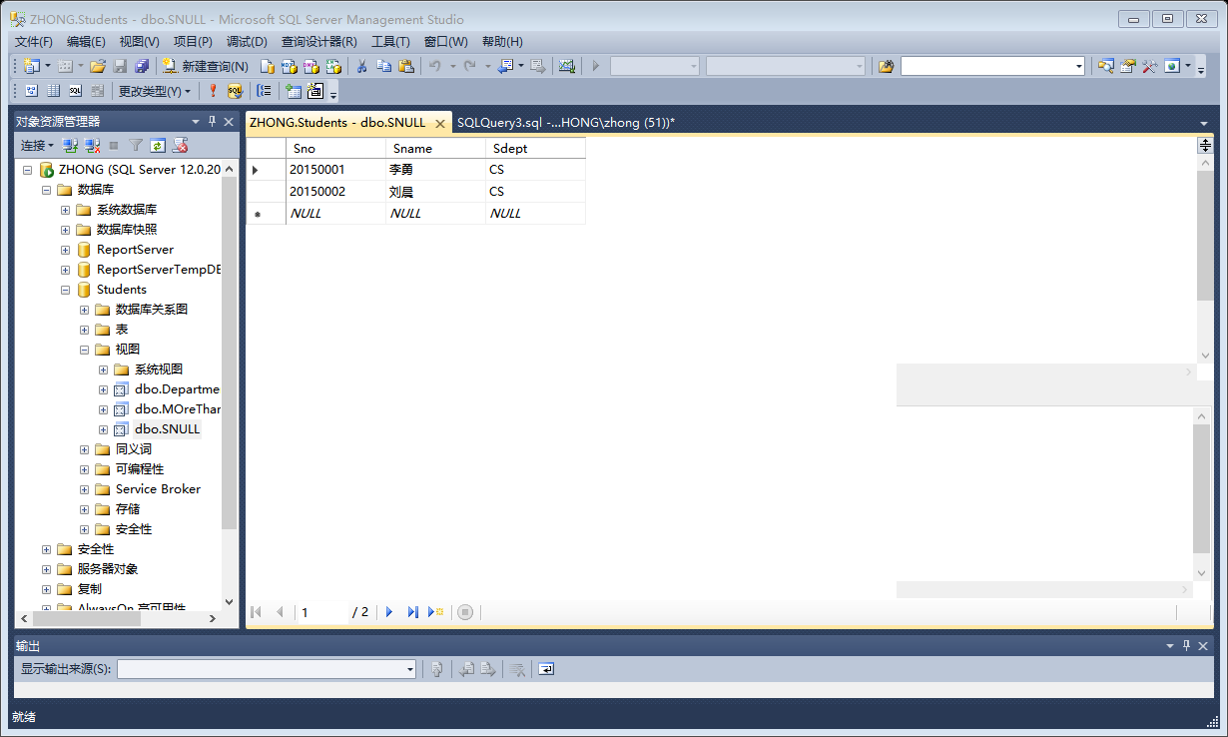

create view Sgrade as

select Student.Sno,Cname,Grade

from Student,Course,SC

where Student.Sno = SC.Sno and SC.Cno = Course.Cno;

select Cname,Grade

from Sgrade

where Sno = '20150008';

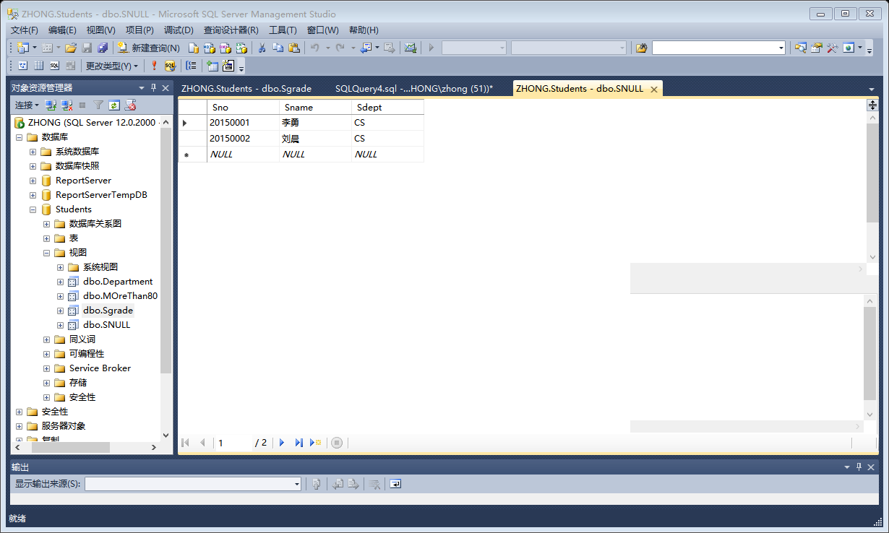

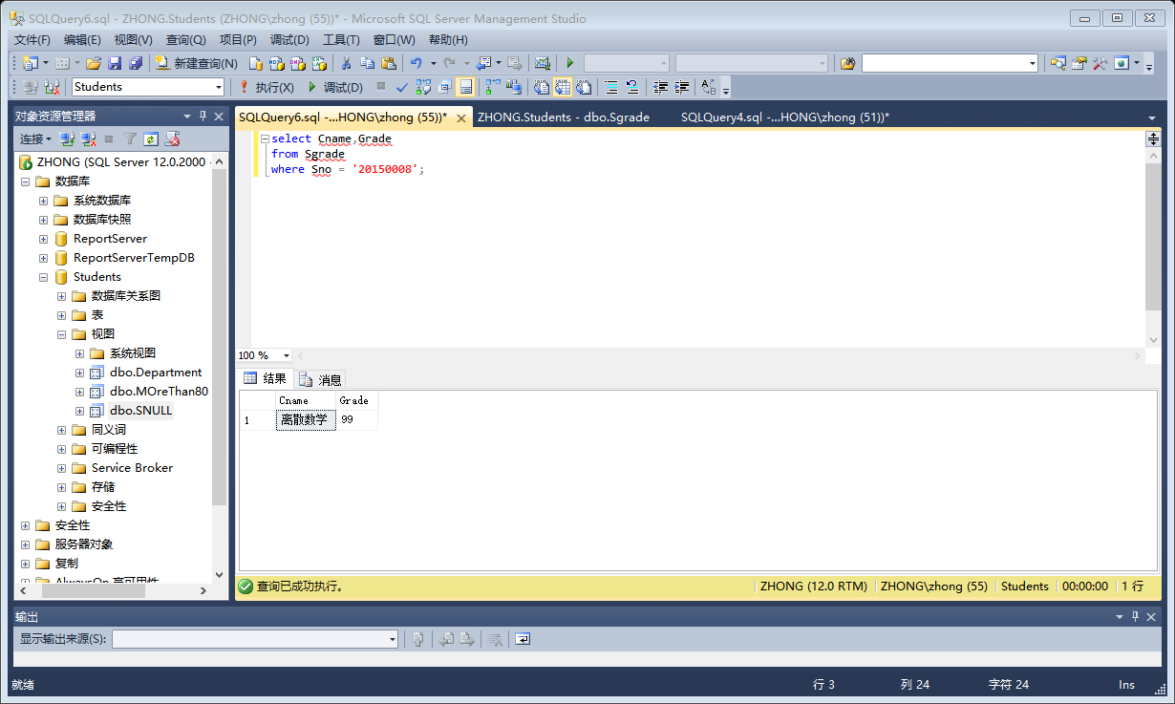

create view InfoCourse as

select SC.Cno,Count(\*) SNum ,AVG(Grade) GAve,MAX(Grade) GMax

from SC

group by SC.Cno;

select SNum,GAve,GMax

from InfoCourse where Cno = '3'

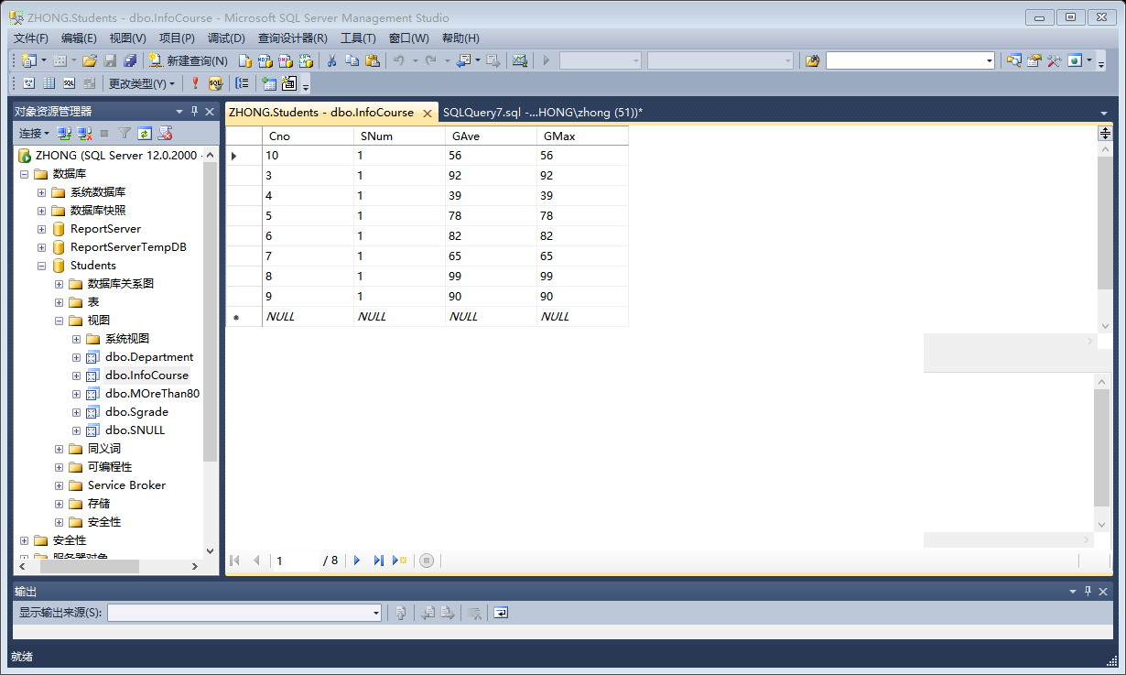

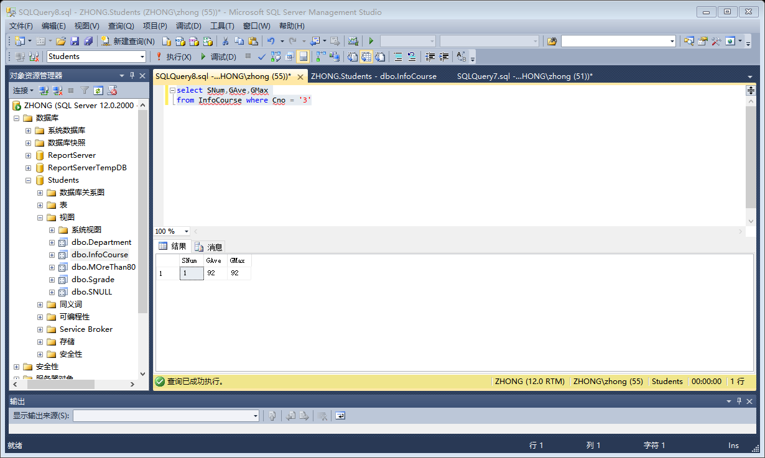

create view MoreThanAvg as

select Student.Sno,Grade

from Student, SC,Course

where SC.Cno = '4'and

Student.Sno = SC.Sno and

SC.Cno = Course.Cno and

Grade>(select avg(Grade)from SC group by Cno );

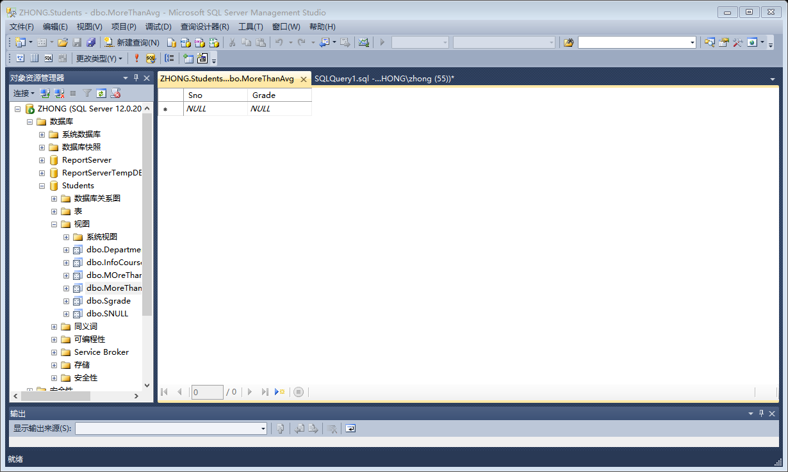

grant select

on Student to user1;

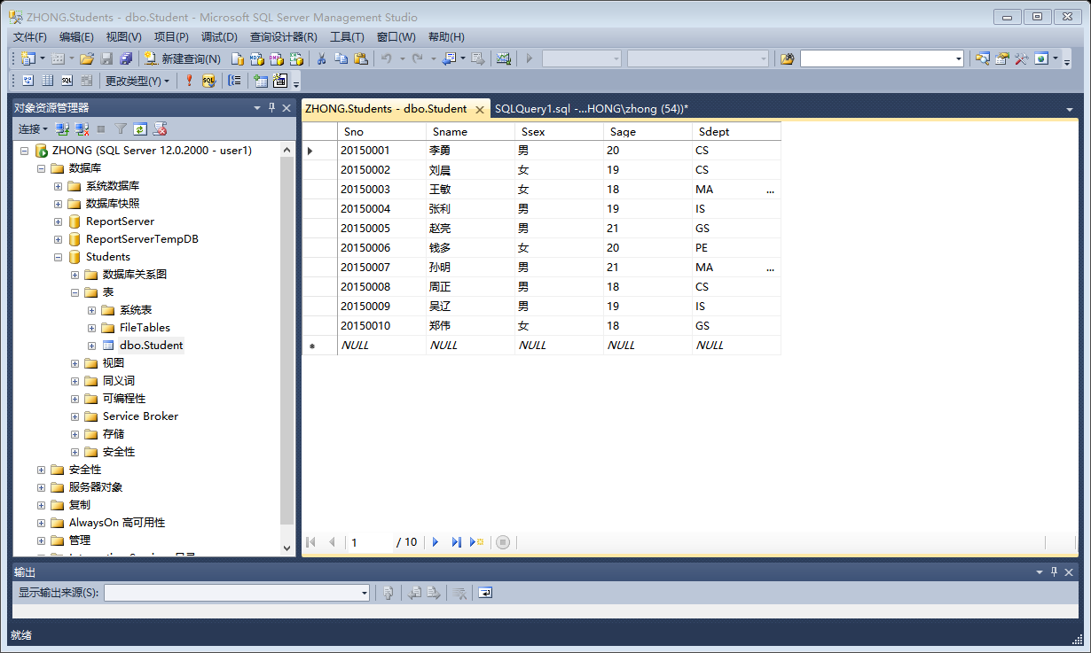

revoke select

on Student

from user1;

